**DEATS**

**VERSION 1.00**

**TITLE Differential Expression Anatomy Term Sheets**

**AUTHORS: Seve**

**AFFILIATION University of Oregon**

**Overview**

**How the DEATS Generator Works**

By reviewing scientific research, the ZFIN database has been gathering data that connects zebrafish genes (starting with ENSDARGs) to zebrafish anatomy (ZFA & BSPO). The DEATS Generator leverages this information to help label unidentified cell-types from single-cell RNA seq. Our program goes into the ZFIN database, finds the zebrafish anatomy associated with the zebrafish genes the user has input, and generates a *differentially expressed anatomy term sheet*, or DEATS, table, displaying which anatomy terms are associated with the input and how many times these anatomy terms were found.

**Why make a DEATS table?**

DEATS tables were envisioned by the ZFIN organization as a method for labeling unidentified cell-types using single-cell RNA sequencing data. Single-cell RNA sequencing data, which can show genes differentially expressed between cell-types, provide tremendous insight into the differences between an organism, or a tissue’s, cell-types. Unfortunately, one of the things currently unautomated is the use of data to label the cell-types present organism or tissue. The DEATS generator looks to solve this problem by using the expertly curated ZFIN database to create a simple table which shows the anatomy most often associated with the cell-types differentially expressed genes. In most cases the top values in the DEATS table can be used to determine a suitable label for the unidentified cell-type of interest.

This program uses the published anatomical locations of a gene's expression and a list of Differentially Expressed Genes for a Cell-Type to create a Differentially Expressed Anatomy Terms Sheet (DEATS). DEATS can be used to annotate one or multiple zebrafish cell-types.

**TERMS:**

**Pete Score:**  Ratio of (Pct-1/ Pct-2) * Avg Log FC

Where,

Pct1 – Percentage of genes differentially expressed in a cluster

Pct2 – Percentage of genes differentially expressed in all cluster

Avg Log FC – Average Log Fold Change

**2.How to use this tool:**

1. **Inputs**
2. Choose Developmental stage you are interested in, from the drop-down menu.

e.g.

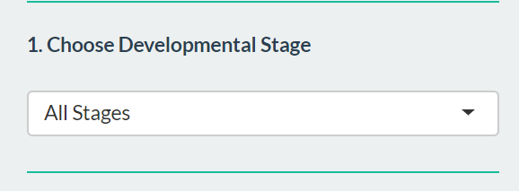

In this example, we choose **All Stages.**

1. Upload a list of Differentially Expressed Genes OR Multiple DEG Lists

In this example, we choose **‘**[**Click here for an example DEG List**](https://rayfin.uoregon.edu/shiny-jhp-annotate/annotate/)**’**  option.

Snapshot

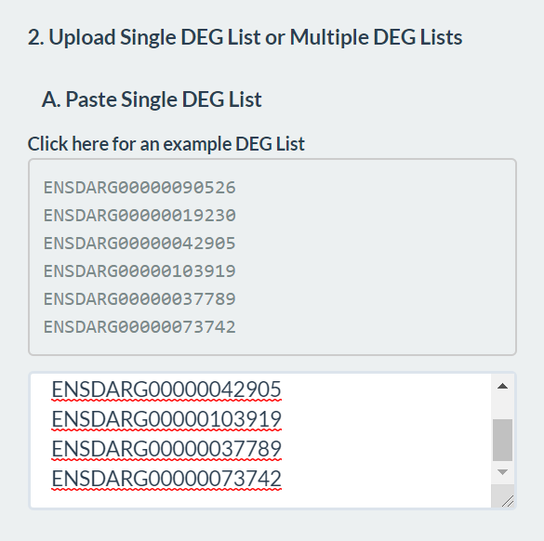

1. You can also use sample list which is already loaded in the box.
2. **Choose PETE score.** More explanation of PETE score can be found in section ‘**TERMS’**

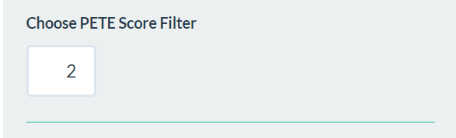

1. **Run!**

Click on the ‘**Go**’ button to start your data annotation.

1. **Results**

Based on Pete score, the program ranks the genes in each cluster in ascending order.

There are total 3 outputs:

1. **Anatomy Term 2.Count 3. P value**

Example snapshot:

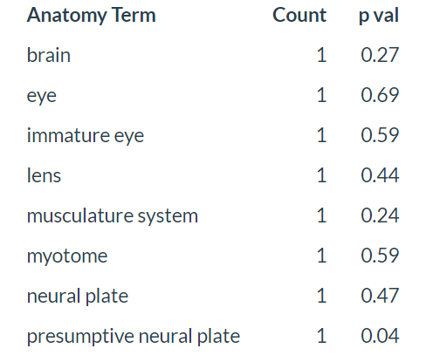

This program outputs list of anatomy terms associated with a particular cell cluster. All the results are in the tab called **‘DEATS’**. Move over to the DEATS tab to view the results. The user can view as well as download the results as per the number of clusters through **‘Download DEATS’** button.



If the user is interested in a particular annotation term, the user has an option to search for the terms in cell-type annotation search-box

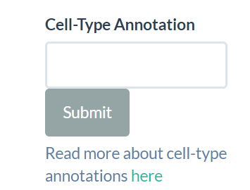

On the top-right corner, user also has an option to view Gene symbols by clicking **‘See Gene Symbols’** button.